English Meal 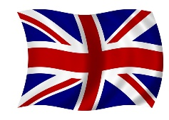
Thursday, May 18th 2017

Starters

¤ Cucumber mint yogurt sauce
¤ bacon and cheese rolls
¤ the salad bowl

Main course

¤Curry beef
¤ Cider and cheese pork chops
¤ Fish with mussels and shrimps in beer sauce

Vegetables

¤ Rice

Cheese

¤ Cheddar cheese

Dessert

¤ Muffins
¤ Brownies



